Programming Fundamentals: Lab-08

BS-CS-F21 Morning

Spring 2022 Semester

Monday 24th of October, 2022

Instructor: Dr. Saadia Shahzad

**Instructions:**

1. Always start with the name of Allah Almighty, most beneficial and most merciful.
2. Read the document carefully before starting.
3. Don’t hesitate to ask any questions from teacher and TAs but not from your fellows.
4. Use of mobile and internet is strictly not allowed.
5. Store your files with the following naming conventions:

Lab Work_<Lab No.>_<student ID>_T_<Task ID>.<extension>

e.g for today’s lab, file names for student BCSF21M001 will be like the following:

* 1. LabWork_08_BCSF21M001_T_01.larp
  2. LabWork_08_BCSF21M001_T_02.c etc.

1. At the end, compress your files in a .zip or .rar file with a name like: LabWork_08_BCSF21M001.zip.

If you are not familiar with this, you can ask TAs.

1. Lab work will be submitted at the end of every lab on LAN in a given folder name.

In case of any negligence/violation of instructions, your lab work will be graded with zero/negative marks.

**TASK 1:**

Write a C program to read elements in a matrix and interchange elements of primary(major) diagonal with secondary(minor) diagonal.

**Example**

**Input**

Input matrix elements:

1 2 3

4 5 6

7 8 9

**Output**

Matrix after interchanging its diagonal:

3 2 1

4 5 6

9 8 7

**TASK 2:**

**Part (a):**

Create a C program that: stores marks of 3 students for 5 tests in a two-dimensional array such that each row in the array represents test scores for one student. Pass that array to a function that display the average of each student’s test scores on console.

**Sample Output:**

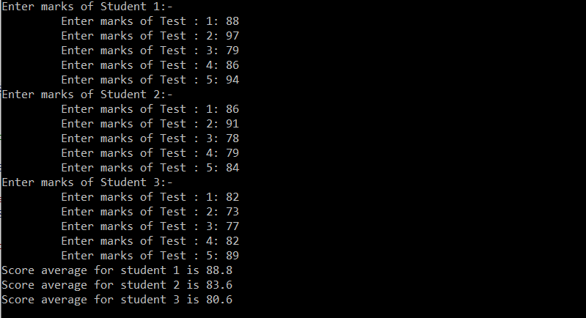

Fig 23. (Post-Lab Task 1)

**Part (b):**

Modify the above program such that it calculates and display average marks of each test using function.

**Sample Output:**

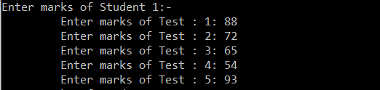

**TASK 3:**

Write a program that lets a maker of chips and salsa keep track of sales for five different types of salsa: mild, medium, sweet, hot, and zesty. The program should use a list of strings that holds the five salsa names and an array of integers that holds the number of jars sold during the past month for each salsa type. The salsa names should be stored using an initialization list at the time the name array is created. The program should prompt the user to enter the number of jars sold for each type. Each jar costs 550 rupees. Once this sales data has been entered, the program should produce a report that displays sales for each salsa type, total sales, and the names of the highest selling and lowest selling products.

Sample Execution:

Enter month: December, 2021 Enter the jars sold for mild salsa: 250 Enter the jars sold for medium salsa: 300 Enter the jars sold for sweet salsa: 212 Enter the jars sold for hot salsa: 110 Enter the jars sold for zesty salsa: 165

Sales Report of December, 2021: -------------------------------------------

Mild Salsa: 250 Medium Salsa: 300 Sweet Salsa: 212 Hot Salsa: 110 Zesty Salsa: 165

Total Sales: 1037 Total revenue generated by these sales (Rs.): 570350 Highest sold product: Medium salsa Least sold product: Hot salsa

**TASK 4:**

Write a C program which:

* Takes list of 5 strings from the user.
* Pass the list of strings to the function **sort()**
* The function sorts them alphabetically and display the sorted list on console.

**OUTPUT:**

Enter 5 Strings:

Ball

Apple

Dog

Cat

Egg

Original array: Ball Apple Dog Cat Egg

Sorted array : Apple Bat Cat Dog Egg

You can use: **strcpy(string1, string2)** method to copy the string values from one array index to another in order to swap them. **strcmp(string1, string2)** method to compare the two strings lexicographically and returns the difference between them 1. Returns 0 if strings are identical 2. Returns +ve difference if string1 > string2 3. Reruns -ve difference if string1 < string2

**TASK 5:**

Write a program that creates an integer two-dimension array of size 5x5, populate the array with random values between 0 – 1000. Use rand( ) function to generate random values. The program should then display the largest and smallest values stored in the array.

For this task implement following functions:

a) void populateArray(int arr[ ][5]) b) void display(int arr[ ][5]) c) int findMin(int arr[ ][5]) d) int findMax(int arr[ ][5])

**Coding is today’s language of creativity. All our children deserve a chance to become creators instead consumers of computer science**

***--- THE END---***